**ErrorCats -** Jackson Feng, Jordan Oberstein, Ryan Hickey, Terry Lin, Veevek Dave

**OVERVIEW**

There are several dining halls around Rensselaer. It is difficult to know what food is served without entering. The lack of information poses a problem for students who aren’t on the unlimited meal plan. Every time they enter a dining hall, it is a gamble to know if the food is edible. Enter RPI Foodies, a social media app for all those students wanting to know about dining hall meals. With RPI Foodies, students can post the food served in each dining hall. A picture accompanies each post so students can see what the food looks like before deciding to eat it. Accompanying each photo, students can drop a review of the food to share with other students what the edible food is. With RPI Foodies, students won’t need to worry about risking a swipe and instead head to their desired dining area and eat the food they want. It also greatly helps those with allergies or vegetarians find the dining halls that fit their needs the most without risking a swipe because each post has tags, some of which are vegetarian meal, vegan, or even dessert! RPI Foodies functions like other social media sites, having a feed showing the various foods around campus and the reviews people are giving them. Students can also search specific dining halls and see what food was served, search for a special meal such as desserts, or a particular group of food like pasta.

**STAKEHOLDERS AND USERS**

All students of RPI are potential stakeholders. First-year students and sophomores hold higher priority, as they must live on campus and have a meal plan than upper-level students. Students' parents would also be stakeholders because they could see what their children eat. RPI Foodies allows parents to ensure their children are getting proper meals and that the school does not provide lackluster food to their students. Sodexo, the company supplying RPI with food, would also hold a stake in RPI Foodies. With data from the software, they could see which dining halls produced the best food and which food students liked.

On top of that, Sodexo could use the data to find what food suppliers they need to rely more on because students enjoy the food they provide more. Along the same lines as Sodexo, Rensselaer Dining is a potential stakeholder. They, similar to Sodexo, would have access to troves of data which they would use to find the top dishes and most eaten meals. Using the data collected, they could further modify their menus to suit the needs of the students. Rensselaer Dining could also create an account to promote new dishes and locations and, based on user interactivity and related posts, determine if they should release similar foods or try something new. Clubs and organizations holding events that are on campus and provide some food would also be stakeholders. Through the app, they could promote the free food and thus have people show up and would be promoting their club.

RPI Foodies provides data about the least eaten and most hated dishes. Rensselaer Admins, having access to that data, could see what food they had to buy to save money. In addition, because Sodexo buys food from local farms, the farms closest to Troy would also be stakeholders. They would see which foods students eat the most and, from there, change their crops to fit the needs of the students better.

**FEATURES**

As of now we plan on implementing features similar to sites like Reddit and Instagram. Each post will have a picture and a description of the food item. We can also implement a rating scale for the user to rate the food. Once posted, students can react to it through means of emojis and messages. Popular page - posts with the most likes or reactions that have been trending. Categories - posts will be categorized and have separate pages based on the type of food like “vegan/vegetarian items”, “snacks”, “deserts”, etc. Login Page/Create Account Page - every student must create an account in order to post there food time or react to other user’s posts

**TECHNOLOGIES + UI**

For the front end of our site, we plan on utilizing HTML, CSS, and Javascript. We will use HTML to structure our page layouts and components and then CSS to style each component. In order to add functionality to these components, we will add Javascript. For the back end of our side, we plan on using our primary database mySQL to store information about the users, posts, etc. In order for the back end to communicate, we make extensive use of PHP to analyze and rank user likes and comments on features so that we can find the most popular foods and eateries among students, as reflected by the Trending and Best of the Week features.

**FUNCTIONAL AND NON-FUNCTIONAL REQUIREMENTS**

Our application has three functional requirements. The first functional requirement is the ability to post pictures and reviews on the site. Implicitly, this also means the site must have the capability to host large numbers of images. Second, users must be able to review, comment, or react to other photos in some capacity. Third, there must be backend capabilities to collect data on photos and reactions.

Many non-functional requirements stem from these functional requirements. In order to post pictures on the website the app must have access to the phone's camera. When posting a photo, a user needs to be able to add a comment and/or tag alongside the photo. Users must be able to query photos relevant to them, either automatically or manually; the easiest criterion for this is simply location. Administrators of the app must be able to remove photos or posts that are irrelevant to the app’s purpose. Alternatively, this can be done with automatic filters or through users reporting posts or comments. Data that the app collects must be stored in a manner such that it can at least be exported into a format useful for Sodexo or other stakeholders. This is intended to be a site that can be used easily by phones and viewed on a laptop. Therefore mobile platform compatibility is crucial to ensure a satisfying user experience.

**SiteMap**

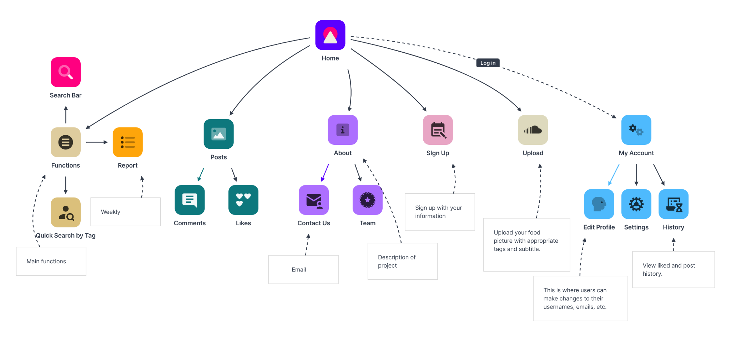

This sitemap is a blueprint that shows the basic structure and functionalities of our website. The different branches descending from Home indicate the different accessibilities the user has on the main page of our website. The subbranches are additional functionalities accessed via their mother branch.

**WireFrame – Main**

We chose to use Axure RP to make our wireframe into a mock website, we think it is the best way to show our idea in a virtual wireframe way. Using a mock website we can fully bring out our design. Furthermore, using sharing HTML by Axure RP, we can even make our mock-up in an interactive way.

As for our design, we chose to mimic other social media sites, such as Instagram or Facebook. Having the main feed where users can see what the newest food is and a trending page, where users can see the hottest food of the hour both work very well for other social media platforms in their respective ways, so we chose to have those pages on our site.

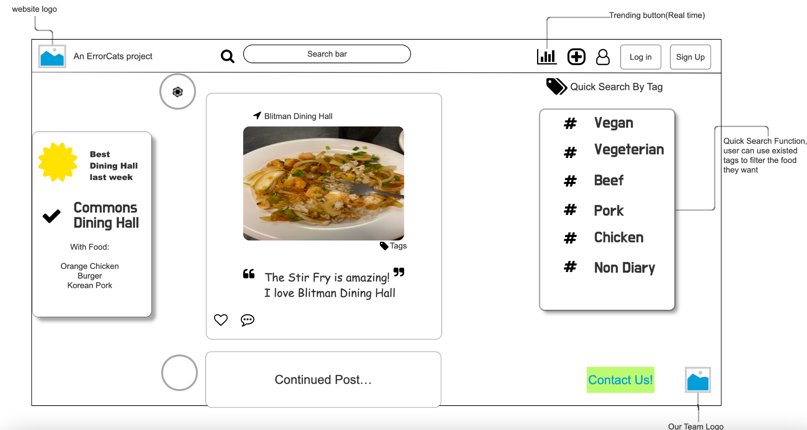

**WireFrame – Trending**

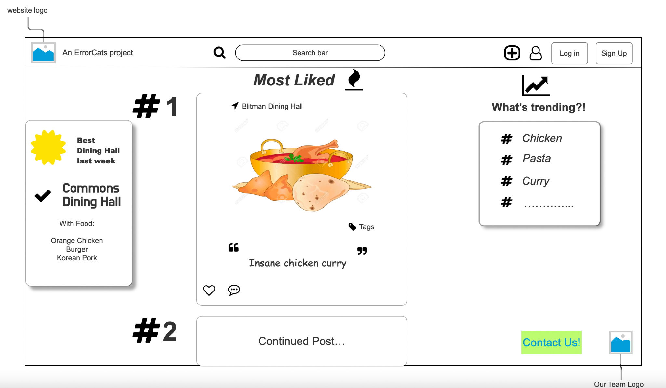

**PROJECT SCHEDULE**

| Date | What should be accomplished |
| --- | --- |
| 10/1/22 | Landing page CSS and HTML |
| 10/15/22 | All pages complete for CSS and HTML |
| 10/29/22 | Landing page js |
| 11/12/22 | All other page js |
| 11/19/22 | Landing page PHP/SQL |
| 11/26/22 | All other pages PHP/SQL |
| 12/3/22 | Final website complete |

Most of our website is based around our main page so that is where the brunt of development is going. Also, because they will all have a similar theme, it will be easy to complete the side pages leading to a faster turnaround. The schedule is subject to change based on how early we relearn and revisit the material needed to complete each section.

**TIK TOK VIDEO!**

<https://drive.google.com/drive/folders/1E-MJUX5TyD6DN76BoWj3HJ_GAvJNOKrF?usp=sharing>